- ISSUES ON REGISTRATION AS IF THERE ARE 3 MEMBERS AND 2ND MEMBER’S ACADEMIC CRITERIA IS NOT MEET THEN IT SHOULD NOT SENT OTP FOR ANY OF THE MEMBER (RIGHT NOW BEING SENT FOR FIRST MEMBER)
- NO USER GUIDELINE WHEN FYPGROUP WITH STATUS ‘PENDING’ LOGINS – UI LOOKS VERY SIMPLE, ADD ICONS ETC TO MAKE IT MORE ATTRACTIVE
DONOT REMOVE THIS, MAKE IT PERMEMANT FOR ALL STATUS OF FYP
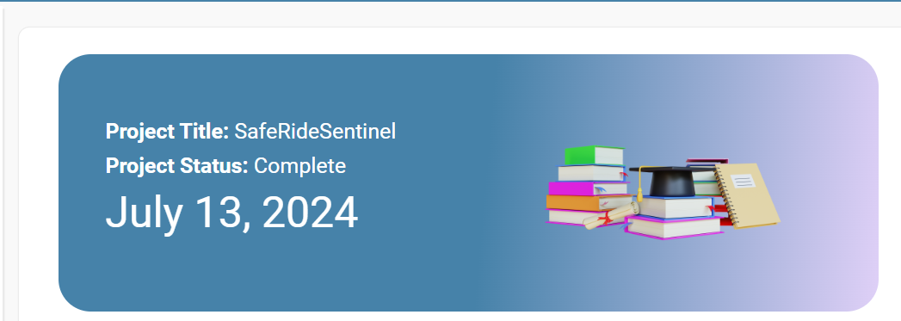
sample – CODE IS ALSO PROVIDED LOOK TO JUST INTEGRATE
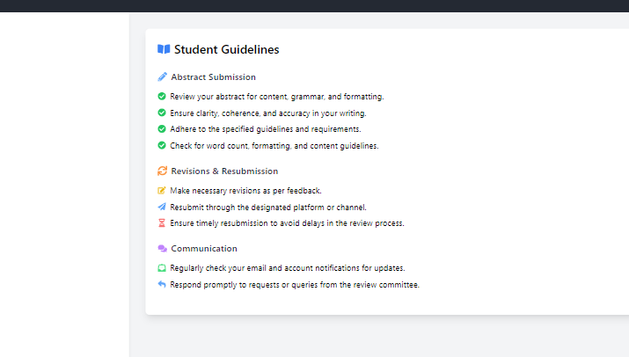

- LOGO NOT CHANGED – UPDATED LOGO TO BE PROVIDED:


- NO VALIDATIONS ON SUPERVISOR SCREEN FOR ADD, DELETE OPERATION (API RETURN MESSAGE, SHOULD BE SHOWN ON UI) – STILL NO LOADER WHILE ADDING SUPERVISOR AS SHOWN IN VIDEO

- FROM WHERE DOES ADMIN RESPOND TO QUERY :
THEN WHAT WILL BE THE PURPOSE OF QUERY AT ALL IF NO RESPONSE IS TO BE PROVIDED?
IT WAS DISCUSSED THAT ADMIN WILL RESPOND BACK TO QUERIES
